The Robert and Bonnie Bennett Residence
1015 W Sugnet Rd, Midland, MI 48640 | Zillow
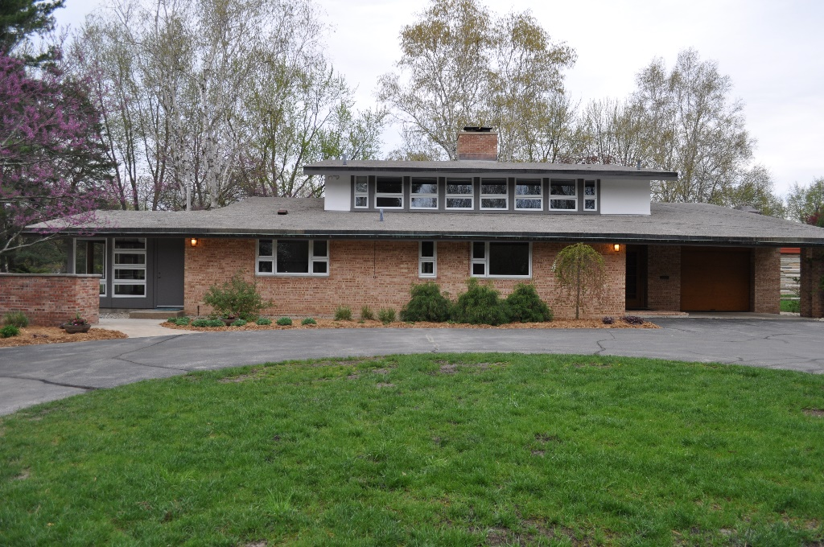
One of a kind Alden B. Dow home, the "Gallery House" is centrally located in the city next to the Midland Country Club and within walking distance of the Grace A. Dow Library, the Midland Center for the Arts, downtown Midland and several area parks.
The house sits on a double lot with a large patio and gorgeous landscaping including mature yews, red and white pines, and several fruit trees (apple, cherry, crabapple, etc.). The brick and stucco exterior is simple with straight lines and is contrasted by the interior that features edge grain fir throughout, mirrors, vaulted ceilings and an inviting open-air design with large windowed walls and built-in desks providing stunning views of the golf course.
The spacious living room and sitting areas feature several beautiful built-ins, including sofas and tables. Two fireplaces in the heart of the home create a warm atmosphere for family and social gatherings.
The spectacular dining room has a glass and wood canopy over the dining table providing enchantment as well as illumination. Bathrooms feature beautiful art deco ceramic tile and timeless features and fixtures.
The updated fully finished basement and workshop provide additional space for music, games and hobbies. 2 new furnaces were installed in 2010. Documentation for the home is preserved in the Dow Archives. This home is truly an architectural treasure located in a beautiful neighborhood providing a wonderful environment to raise a family.
